The Companying bar graph shows the percentage of reservation that are canceled and those that are not. It obvious that there are still a significant number of reservations that have not been canceled. There are still 37% of clients who canceled their reservation, which has a significant impact on the hotel’s earnings.

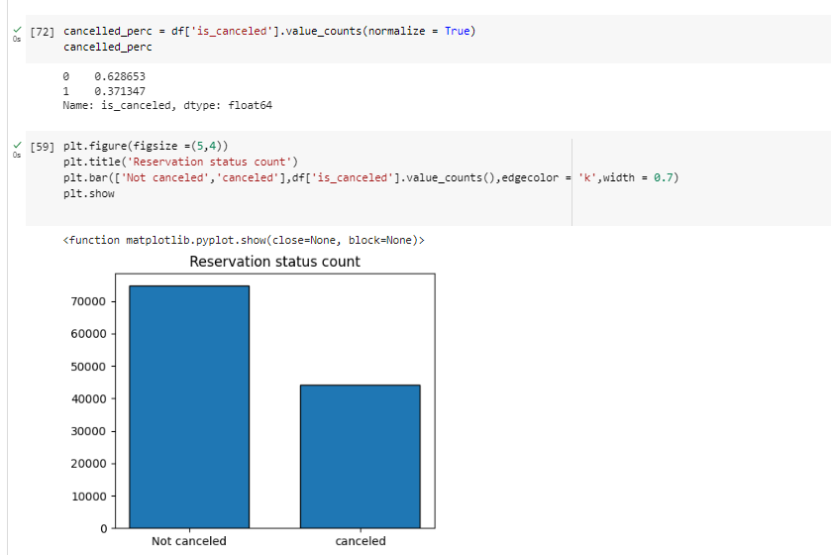

In comparison to resort hotels, city hotels have more bookings. It’s possible that resort hotel is more expensive than those in cities. 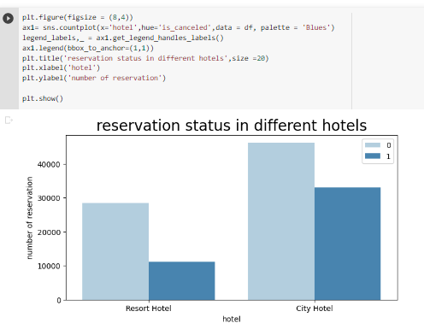

The line graph above shows that, on certain days, the average daily rate for a city hotel is less than that of a resort hotel, and on other days, it is even less. It goes without saying that weekends and holidays may see a rise in resort hotel rates.

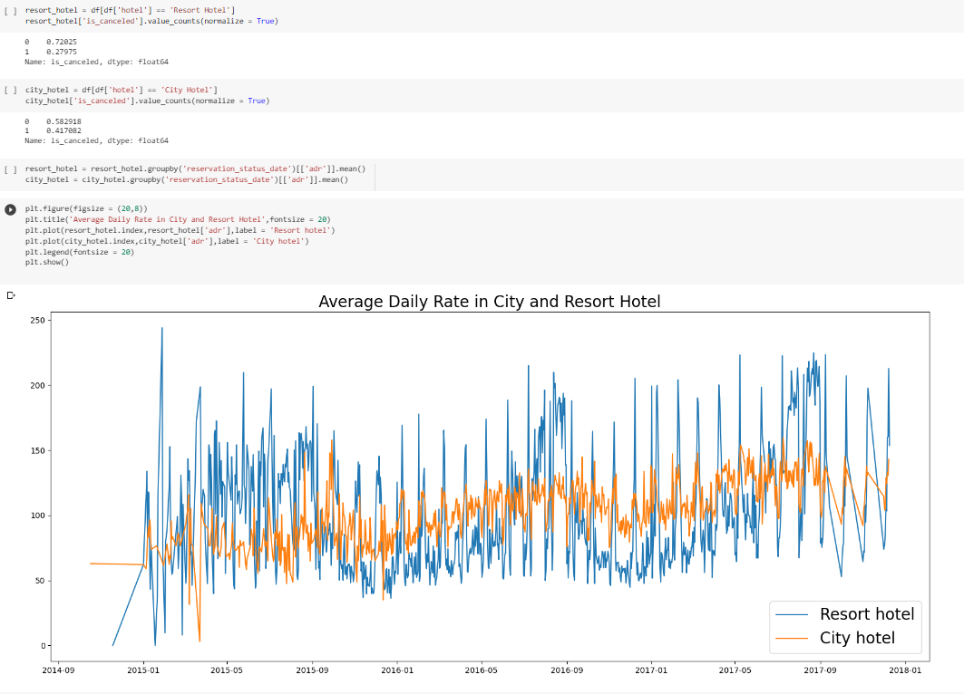

I have developed the grouped bar graph to analyze the months with the highest and lowest reservation levels according to reservation status. As can be seen, both the number of confirmed reservation and the number of canceled reservations is largest in the month of August. Whereas January is the month with most canceled reservations.

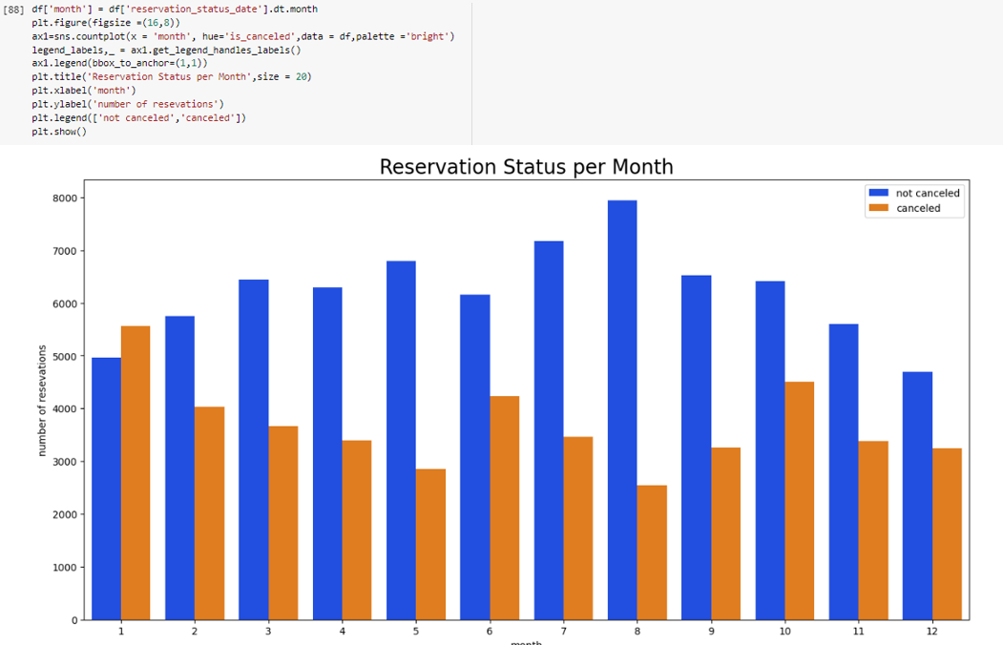

Now let’s see which country has the highest reservation canceled. The top country is Portugal with the highest number of cancellations.

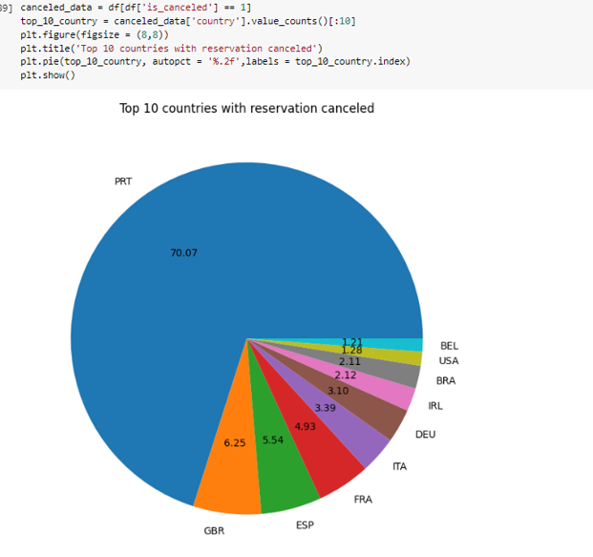

Let’s check the area from where quest is visiting the hotels and making reservations. Is it coming from direct or groups, Online or Offline travel agents? Round 46% of the clients come from online travel agencies, whereas 27% come from groups. Only 4% of client’s books hotels directly by visiting them and making reservations.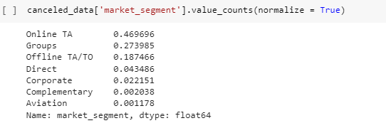

As seen in the graph, reservations are canceled where the average daily rate is higher than where it is not canceled. It clearly proves all the above analysis, that higher price leads to higher cancellations.

**Suggestions**

1. Cancellations rate rise as the price does. In order to prevent cancellations of reservations, hotels could work on their pricing strategies and try to lower the rate for specific hotels based on locations. The can also provide some discounts to the consumers.
2. As the ratio of the cancellations and not cancellations of the resort hotel is higher in the resort hotel than the city hotels. So the hotel should provide reasonable discounts on the room price on weekend or on holidays.
3. In the month of January, hotels can start campaigns or marketing with a reasonable amount to increase their revenue as the cancellation is the highest in this month.
4. They can also increase the quality of their hotels and their services mainly in Portugal to reduce the cancellations rate.